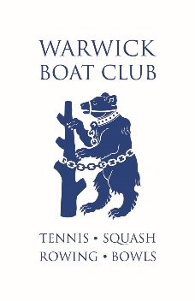

WARWICK BOAT CLUB CHANGING ROOMS POLICY

WBC strives to ensure that all children are safeguarded from abuse and have an enjoyable tennis experience.

This document sets out the Warwick Boat Club policy for the acceptable use of our changing rooms.

**Your children’s health and safety**

1. Children aged 12 or under must be supervised at all times by a member over the age of 18. However, this does not apply if it is club organised activity which parents and guardians do not need to attend (we call this a ‘supervised activity’).
2. In WBC family changing rooms are not available. Children over the age of eight can use the changing rooms without supervision.  Children over 8 must use the changing room in accordance with their gender.  Adults must show respect and decency when changing and this includes appropriate ‘covering’ when changing and or showering where young people are present.
3. If you cannot bring your children to a supervised activity, you can nominate a responsible person to bring them instead.
4. If your child is at a supervised activity, he or she must be registered with the person in charge of the activity, who must also have details of who will be collecting your child. We will not allow any other person to collect your child unless you have made a specific arrangement beforehand with the person you have left your child with.
5. Our coaches and volunteers in charge are sport accredited coaches and as such are DBS -checked.  They follow the relevant guidelines of National Sporting Body’s/councils/NSPCC.
6. You must not bring your children into the club if they have an infectious illness or condition.
7. Appropriate forms must be completed when children are attending clubs or training sessions.  Parents and guardians must liaise with coaches or Administration to ensure these are completed prior to attending organised coaching or sporting activities.

**Safeguarding of young people and vulnerable adults**

1. Safeguarding at Warwick Boat Club is everybody’s responsibility.
2. [www.safeguardingwarwickshire.co.uk](https://www.safeguardingwarwickshire.co.uk/) is a website for adults, children, young people, families, and professionals to keep everyone in Warwickshire safe and protected from harm of abuse and neglect.
3. You must follow the guidance of WBC website in relation to current safeguarding advice.  This may change in accordance with local or national guidelines.
4. If you have concerns which need to be addressed by WBC please contact Administration or contact one of our welfare officers directly.  Contact details are on the notice board or WBC website.